**CS691 - Computer Science, Spring 2020**

**Project Initiation Document**

Project: Pet-a-Dog

Project Manager: Kuntal Surwade

Start Date: 2/4/2020

Completion Date: 5/4/2020

Table of Contents

Document Purpose 3

Background to the Proposed Work 3

Vision 4

Project Objectives 4

Project Scope 4

Business Case 6

Assumptions 8

Constraints 9

Risk Management Strategy 9

Deliverables 10

Stakeholders 12

Project Team 12

Project Plan 14

Project Controls 14

Communication Plan 15

Document Details

|  |  |  |  |
| --- | --- | --- | --- |
| Version | Modifications | Author | Date |
| 1.0 | Initial PID Document | Kuntal Surwade | 2/7/2020 |
|  |  |  |  |
|  |  |  |  |
|  |  |  |  |

Approvals

This document requires the following approvals:

|  |  |  |  |  |
| --- | --- | --- | --- | --- |
| Name | Role | Signature | Date | Version |
| Yuri Chernak | Professor |  |  | 1.0 |
|  |  |  |  |  |
|  |  |  |  |  |
|  |  |  |  |  |
|  |  |  |  |  |
|  |  |  |  |  |

Distribution

This document has been distributed to:

|  |  |  |  |
| --- | --- | --- | --- |
| Name | Role | Date of Issue | Version |
| Kuntal Surwade | Project Manager | 2/7/2020 | 1.0 |
| Harivatsav SR. | Product Owner | 2/7/2020 | 1.0 |
| Bhakti Shastri | Lead Business Analyst | 2/7/2020 | 1.0 |
| Khalid Francis | DBA | 2/7/2020 | 1.0 |
| Prathmesh Pathak | Lead Developer | 2/7/2020 | 1.0 |
| Soham Save | QA Tester | 2/7/2020 | 1.0 |
| Aditya Aduri | QA Tester | 2/7/2020 | 1.0 |

# Document Purpose

This document has been created to record the basic information needed to manage the project. The document will describe the scope, objectives, tasks, roles and responsibilities, costs and deliverables related to “Pet-a-Dog” website application. This document is the Project Initiation Document (PID) for the Pet-a-Dog Web Application Project. The purpose of this document is to define the project and form the basis for its management and the assessment of overall success. It will communicate the scope, objectives, tasks, roles and responsibilities, costs and deliverables relating to the Pet-a-Dog Web Application Project.

The PID dictates the following critical aspects:

* Details of the approach to be adopted for the implementation of the “Pet-a-Dog” Web Application Project.
* Details of the roles and responsibilities.
* Description of functions and activities.
* Explanation of the processes.
* Details of the communication plan between team members and with the stakeholders.
* Quality records, risks, project controls and exceptions.

The sections of this document are dynamic and could potentially change over the lifetime of the project. The changes will be recorded in the PID document. The PID will be referred each time when a major decision is taken about the project. Also, the PID document will be used at the end of the project to measure whether the project was managed successfully or not and whether all deliverables were produced in a timely manner or not.

# Background to the Proposed Work

According to American pet association survey dog owners in the United States spent approximately around 75 billion dollars on their pets and other related services in 2019, which recorded a 4% growth in their spendings from their previous year. 471 million dogs are owned as pets globally in the year 2018. A study also says that the bond established between the people and their pets contributes to better health benefits to both pets and their owners. At “Pet-a-dog” we provide services that would bring dog owners and their dogs much closer without being interrupted by their busy schedule. We provide a clutter free technology where we connect dog owners with the people who are passionate and takes expert care of dogs, also providing tips and information about dogs, dog care and other local events and other related recommendations making pet care easily accessible, convenient, affordable and safe to everyone, to experience the unconditional love of their dogs along with their busy schedule without worrying about their pets care and health.

# Vision

Our application would make people think and believe that having a pet that they always wanted or dreamed of having along with their daily routine would actually not be a bad idea.

# Project Objectives

· Create an adaptable and user-friendly interface.

· To create an online trustworthy and loving dog care service that shows available sitters in your city.

· Register user with login and password. [One Time payment to become a member? And afterwards based on the services]

· To provide details like, how many sitters available nearby your location, what type of services would be provided, charges etc.

· To set up in-person interview [Optional]

· Provide booking and cancellation.

· Users will be able to write a review of pet care professionals they hired.

· Users will have an option to book the same sitter for further services. [Based on availability]

# Project Scope

Our scope is to create a dog care service website which deals with following scope categories.

Technical:

* To apply the best UX/UI practices.
* To decide what DB to use.
* To decide what SDLC methodology to implement.
* To discuss roles and responsibilities in a team.
* To install the required software.
* To ensure that the team members have necessary skills.
* To set up development, staging and production environments.

Functional:

* Users will be able to view the sitters available for hire.
* The third party provider will be able to see if the service is booked along with the sitter’s information and also has the right to approve or disapprove of the booking.
* Users will be able to book the sitter and can check the approval status.
* Users will be provided with booking confirmation on Email or contact number after successful booking and payment procedure.
* Sitter ratings will be available for users.

# 

# 

# 

# Business Case

Business Case

Business case information can be structured by completing the table below.

|  |  |
| --- | --- |
| **Application Name** | Pet-a-Dog |
| **Type of business model** | Freemium and Membership Business model |
| **Target audience of external users** | For whom are we creating value?   * Dog Owners   Who are our most important customers?   * Working Customers who don’t have time to take care of their pets. |
| **Groups of internal stakeholders, users** | Do we need a product development group?  No.  Do we need a sales group?  No.  Do we need a finance group (accounts payable, receivable)?  Yes.  Do we need a customer support team?  Yes.  Do we need an advertising management group?  Yes. |
| **Value propositions** | What value do we deliver to the customer?   * Pets safety with good services.   Which one of our customer’s problems are we helping to solve?   * Customers who have no time to take care of their dogs. * Customers who have no expertise or knowledge about how to take care of dogs.   What bundles of products and services are we offering to each Customer Segment?   * We are providing detail tips and guide to customers about taking care of their dogs. * We are providing different services as per the plans selected. Services like dog walk, dog feeding, dog bathing, dog grooming, etc.   Which customer needs are we satisfying?   * We are taking care of their dogs for them. |
| **Key resources** | What Key Resources do our Value Propositions require?   * Human Resources : Dog Trainers   Our Distribution Channels?   * Internet   Customer Relationships?   * Personal Assistance * Dedicated Personal Assistance * Self Service   Revenue Streams?   * Service Fees * Membership fees * Advertisements |
| **How the system is used** | What are the main business use scenarios?   * Dog Owners will get to learn about how to take care of their dogs with our tips and resources. If a dog owner wants someone to take care of their dogs or other specific services, then they have to subscribe. |
| **Revenue generation, Revenue streams** | * Advertisements * Service fees * Membership fees |
| **Key Partners/Suppliers**  **(Stakeholders)** | Local Salon/ Spa, Advertising Media, Source Provider, Bank, Credit Card Vendors. |
| **Expected Benefits** | * Dog Owners will get notifications for dog related events like dog shows/cat shows. * Dog Owners will get useful tips and resources on taking care of a dog. * Membership benefits, such as free cancelation fees, first service free, after every 10th service- one service will be free. * Service tracking will be provided. |
| **Known Prototypes** | Rover.com, Wag app, care.com |

# Assumptions

|  |  |  |  |
| --- | --- | --- | --- |
| Assumption | Validated by | Status | Comments |
| Participation Time | All Members | Completed | All members have decided to at least provide 6 hours per week to this project |
| Keep Same Technology for development | Business Analyst | In Process | Business Analyst will keep track of latest Technologies |
| Team Work | Manager | In process | Manager will keep details of all Modules and will assign ‘Single or Team’ work on specific modules. |
| Requirements will not change | Owner | In Process | Owner is responsible for the requirements of the project and will decide main features before the development. |
| Meetings (At least Twice a week) | Manager | In Process | Manager will Schedule meetings at least twice a week |
| Team members will stay same | All | Completed | All team members have decide to take Project 2 for next sem |

# Constraints

The aspects that were taken into consideration during delivery of the project are

* Web Application for all browsers and platforms.
* All the deadlines assigned will be met accurately.
* Availability of Human Resources and funding.
* Time. Project team members have other class and work obligations.

# Risk Management Strategy

This section will include the risk mitigation and management techniques and strategies that will be applied to the project. This may be presented in the following format:

|  |  |  |  |
| --- | --- | --- | --- |
| Risk | Probability | Impact | Mitigation Method |
| Vague and Ambiguous Source  Code | Medium | High | Source Code should be properly planned before starting the programming part. Each team member has to participate in the planning and developing phase and the process should be lead by the Lead Developer of the team. |
| Schedule and Communication Risk | Low | High | The team has to decide the proper day and time to meet each week, and divide the work among each member. Not all team members may be present at each meeting due to timing conflicts or personal constraints. |
| Human errors | High | High | Human errors and modifications should be tested before the delivery of each module and final product.  Proper planning should be made of testing each module at a given time and it should be lead by the tester and helped by the developer. |
| New technology | Low | Low | Lead developer want to use new technology to implement but other team members may take more time to learn about this technology. |

Alongside this, there should be a summary of the most significant risks threatening the project.

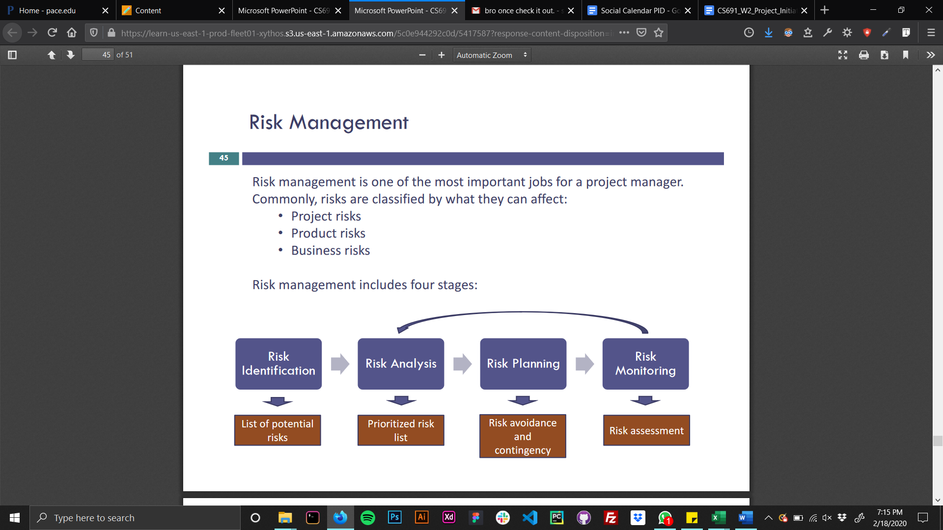

* Risk Identification is the process in which the team identifies the potential risks that may occur during the project’s life cycle. These risks may include issues with the team or technical risks.
* Risk Analysis is taking the list of potential risks and identifying how likely they may occur and what are the potential impacts that they may have.
* Risk planning is the process of creating a backup plan on how to deal with the risk if it occurs. This will help the team handle the risk when it occurs and minimize the potential impacts it may have on the overall project.
* Risk monitoring is a continuous process in which the team monitors and identifies the risk as it occurs. This is also one of the most important as this step is where risk is identified and the risk planning takes action.

# Deliverables

|  |  |  |
| --- | --- | --- |
| **No** | **Artifact Name** | **Responsible Party** |
| **1** | Project Plan | PM |
| **2** | PID document | PM |
| **3** | BRM Diagram | Product Owner |
| **4** | Context Diagram | Lead BA |
| **5** | Architecture Diagrams (2) | Lead Dev/DBA |
| **6** | User Requirements | Product Owner |
| **7** | RCT (includes func. decomp., supplementary reqs) | Lead BA |
| **8** | Use-Case Diagram (UML) | Lead BA |
| **9** | Activity Diagram (UML) | Lead BA |
| **10** | Data-flow Diagram | Lead BA |
| **11** | Functional Requirements (user stories) | Lead BA |
| **12** | Class Diagram (UML) | Lead Dev |
| **13** | Sequence Diagram (UML) | Lead Dev |
| **14** | ER Diagrams (conceptual, logical) | DBA |
| **15** | Table Specs | DBA |
| **16** | Source code sample (part of Application Demo) | Lead Dev |
| **17** | Test Plan document | Lead QA |
| **18** | Application Demo | All |

# Stakeholders

|  |  |
| --- | --- |
| Stakeholder | Interest |
| Advertisement Sales Management | Advertise web application |
| Finance Management | To manage company finances. |
| Customer Support Manager | To provide satisfactory customer support services |
| Subscription account management | To maintain accounts of subscribed customers. |
| Special service management | To manage all special services provided to customers. |
| End Users | The person or the organisation using the product. |

# Project Team

Project Manager : Kuntal Surwade

Product Owner : Harivatsav Srinivasa Murthy Raghvendra Rao

Business Analyst : Bhakti Shastri

Lead Developer : Prathmesh Pathak

Database Admin : Khalid Francis

Quality Assurance Tester : Soham Save

Quality Assurance Tester : Aditya Aduri

Roles and Responsibilities of the team roles are defined in the RACI Table below:

|  |  |  |  |  |  |  |  |  |
| --- | --- | --- | --- | --- | --- | --- | --- | --- |
|  |  | **Project Roles** | | | | | |  |
| **Process Area** | **Project Tasks** | Project Manager | Product Owner | Dev Lead | Business Analyst | Test  Manager | DBA | Tester |
| Project Management | Develop a project plan | A,R | C | C | C | C | C | C |
| Provide cost estimate | A,R | C | C | C | C | C | C |
| Hire resources | A,R | C | C | C | C | C | C |
| Establish a project portal on SharePoint | A,R | R | I | I | I | I | I |
| Maintain a project risk and issue log | A,R | R | C | C | C | C | C |
| Provide project status reports | A,R | R | I | I | I | I | I |
| Requirements | Perform requirements analysts | A | R | C | R | I | I | I |
| Gather business requirements | R | I | C | R | I | I | I |
| Produce functional requirements | A | I | C | R | C | I | I |
| Design | Produce high-level design specs | A | I | R | C | I | R | I |
| Produce data model | A | I | C | C | I | R | I |
| Produce detailed design specs | A | I | R | C | I | R | I |
| Coding | Establish a code repository | A | I | R | I | I | I | I |
| Develop component code | A | I | R | I | I | I | I |
| Testing | Develop a test plan | A | I | C | C | R | C | R |
| Establish a test repository | A | I | C | I | R | I | R |
| Develop test specifications | A | I | C | I | R | I | R |
| Execute testing, report defects | A | I | I | I | R | I | R |
| Conduct defect review calls | A | I | C | R | R | C | R |
| Produce, deliver defect metrics | A | I | C | R | R | I | R |
| Support test environments | A | I | R | C | C | R | C |
| Deployment | Produce a deployment plan | A | I | R | I | I | R | I |
| Produce deployment procedures | A | I | R | I | I | R | C |
| Deploy software into production | A | I | R | C | C | R | C |

# Project Plan

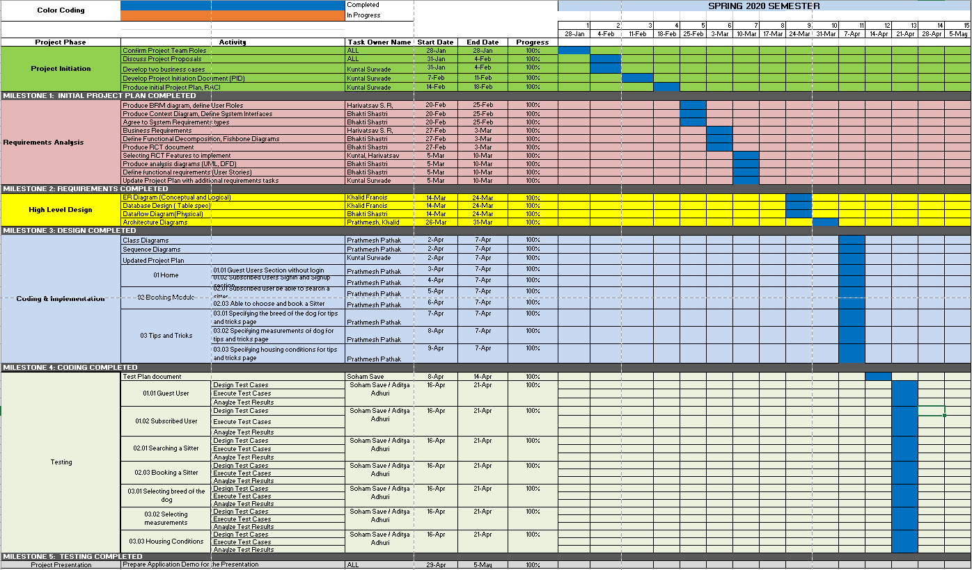

# Project Controls

• Meetings with the Project Manager will be held regularly to monitor progress and manage arising issues. There will be one Monday meeting where the entire group is expected to be present. One or two other meetings will be conducted throughout the week pending on the schedule. These meetings can be remote or in-person.

• The Project Manager will produce regular reports for Professor Chernak and Stakeholders.

• Communication will be done via Email and WhatsApp within the project team. Email exchange will be the primary means of communicating with stakeholders

• Google Drive will be used as a repository for official documentation and will contain all project documentation.

• All source code will be uploaded to PROJECT REPOSITORY TBD.

# Communication Plan

|  |  |  |  |
| --- | --- | --- | --- |
| **Stakeholder** | **Frequency** | **Type** | **Purpose** |
| **Professor** | At key stages - meetings and deliverable drafts | Email | To approve Project implementation and direction. Advise if there are any potential issues. |
| **Project Team** | Daily | Email, Skype for Business, personal meetings, whatsapp, zoom, Slack. | Maintain progress and ensure that the team is meeting weekly requirements. |
| **End Users** | Potentially during the testing phase and after release. | Email, online testing sessions, attend NYC events | Feedback! |